CASES Technical Special Interest Group
TECHNICAL SKILLS WORKSHOP 2026
Delegates based in the UK and Ireland who are registered to attend the Charted Association of Sport and Exercise Sciences Technical Special Interest Group 2026 Technical Workshop can apply for a bursary to cover their travel costs.
The maximum amount of funding that can be applied for is £200. Funding will be awarded if an application meets the criteria, on a first come, first served basis. The funding available is finite, so we encourage delegates to find out whether funding (full or partial) is available from their employer.
If an awardee does not attend the conference for any reason, the attendee must return the funding.
We encourage applicants, where possible, to base their application on the cost of refundable tickets and to purchase refundable tickets when the funding is awarded. It is strongly recommended to prioritise public transport options for travel to the venue.
The bursary can be used to cover the cost of:
- rail tickets (standard class only)
- other public transport (e.g., bus, tram)
- fuel (@45p a mile)
- parking
- accommodation
- air travel
The bursary cannot be used to cover the cost of:
- meals or refreshments
- taxi travel
To apply for the bursary, you must;
- be registered to attend the event and email evidence of this when returning this form.
- live and work in the UK and Ireland
- provide evidence of how much you are claiming for (e.g., screen shots from travel company websites that show prices)
- provide a supporting letter / email from your line manager or supervisor that confirms:
  - that you have permission to take the day off work to attend the conference
  - that funding is not available from your employer to cover your travel costs.
- submit your application via email to enquiries@cases.org.uk by 17:00 on 18th March 2026.
If your application is successful, you will be notified by email as soon as possible.
APPLICATION FORM
Name:
Email:
CASES membership number (if applicable):
Breakdown of estimated travel costs (please note that the table is prepopulated with examples. (Please delete these before adding your own information):
Item | Description | Cost | Note
Tram ticket | Return tram ticket from Beeston to Nottingham station | £5.30 | 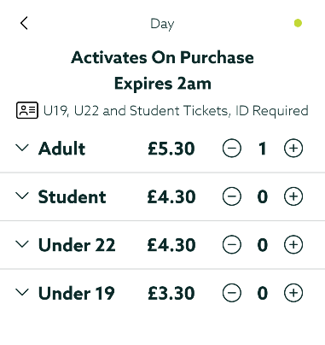
Train ticket | Return trains booked from Nottingham – St Pancras | £192.29 | 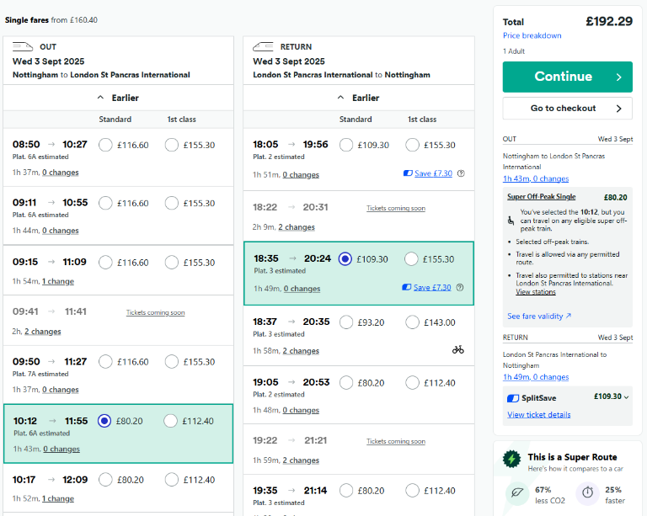
TOTAL AMOUNT OF FUNDING BEING REQUESTED: £150 of total cost £197.89
In order to receive a travel bursary, we require the following information:
- Bank / Building Society Name:
- Sort code:
- Account number:
- Account name:
- Personal or Business account.

Please note, bank details will be deleted once decisions are made about applications and processed.
BEFORE YOU SUBMIT, have you got your:
- evidence of registration
- manager’s supporting letter / email
- additional evidence to support amount being claimed for (if applicable)

Registration confirmation
Insert confirmation of your registration here

Line manager supporting letter / email
Insert line manager supporting letter / email here

IF YOU’RE READY, PLEASE SUBMIT THIS FORM AND SUPPORTING DOCUMENTS TO
enquiries@cases.org.uk by 17:00 on 18 March 2026.

